4) Output lines containing string “CSC 3”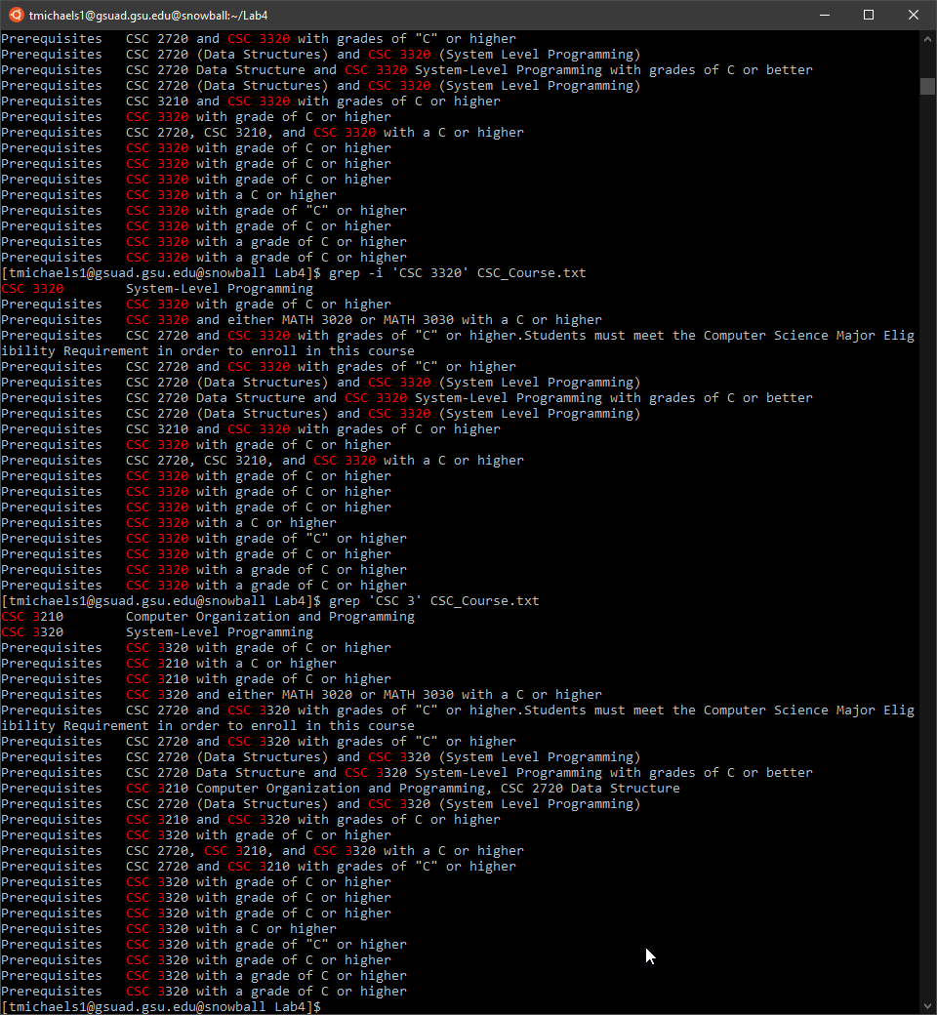

5)this command searches for the string “CSC 3|CSC 1” and outputs nothing since it didn’t find anything that matchs that

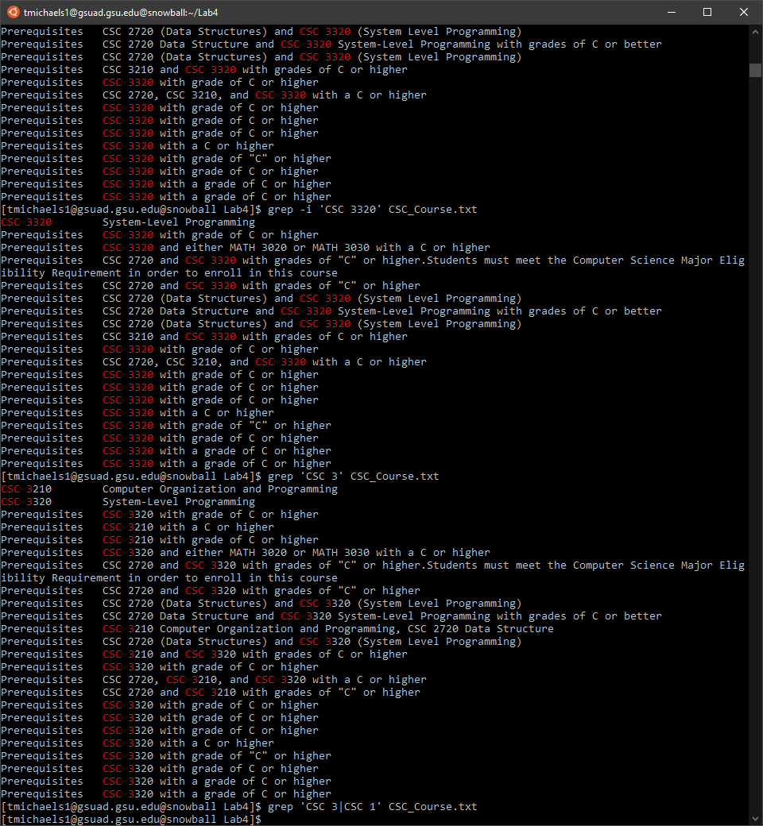

6) this outputs lines in the text that contains “CSC 3” or “CSC 1”

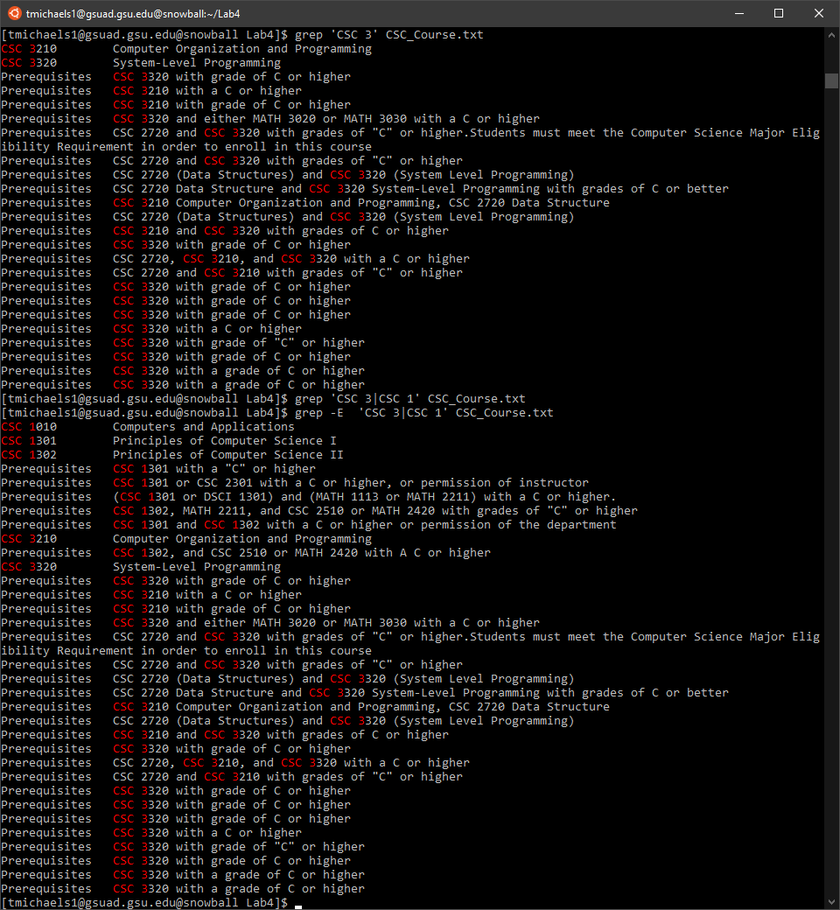

7) this outputs lines in the text that contains “CSC 3” or “CSC 1” which is the same as #6 except it is using the depreciated command egrep

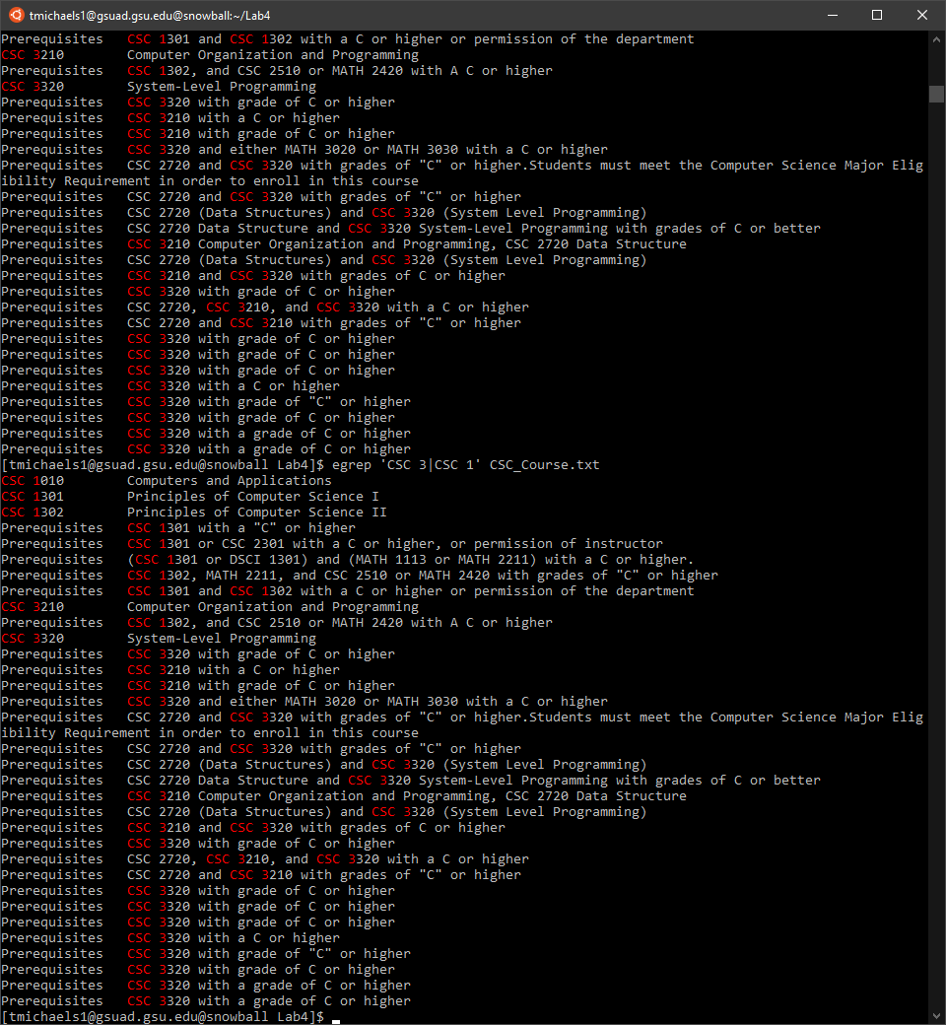

8) has no output

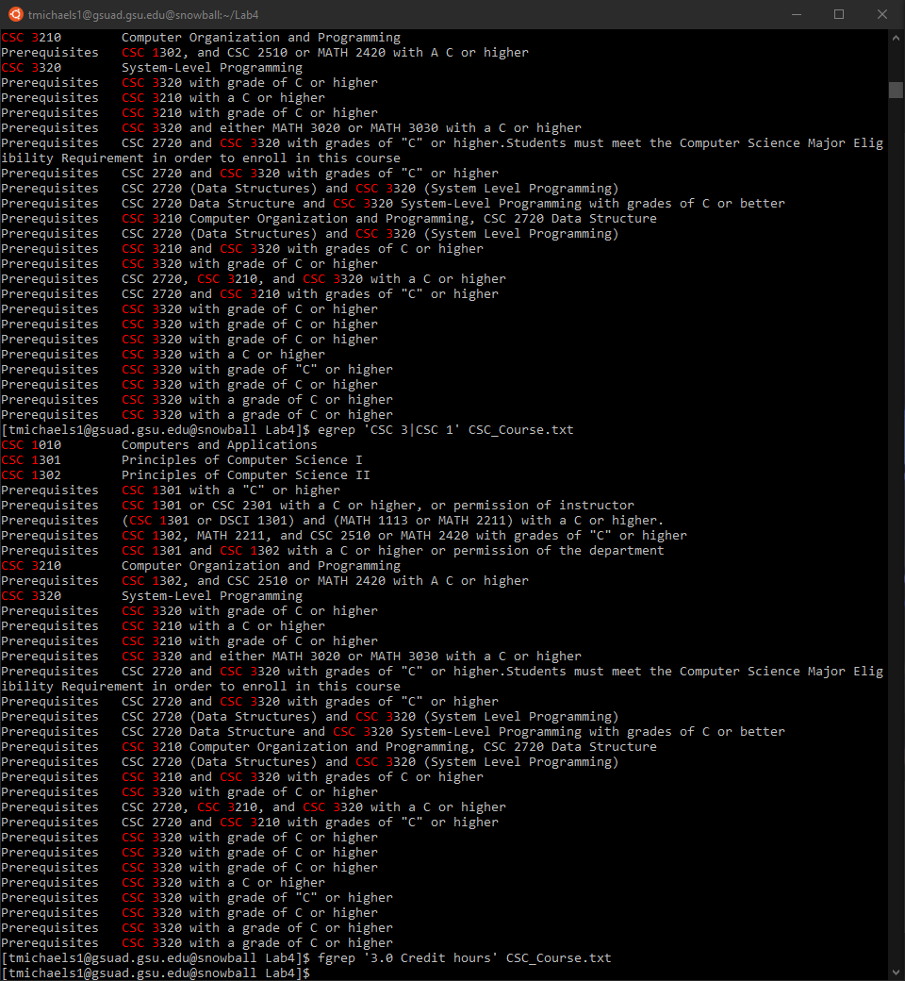

9) has no output

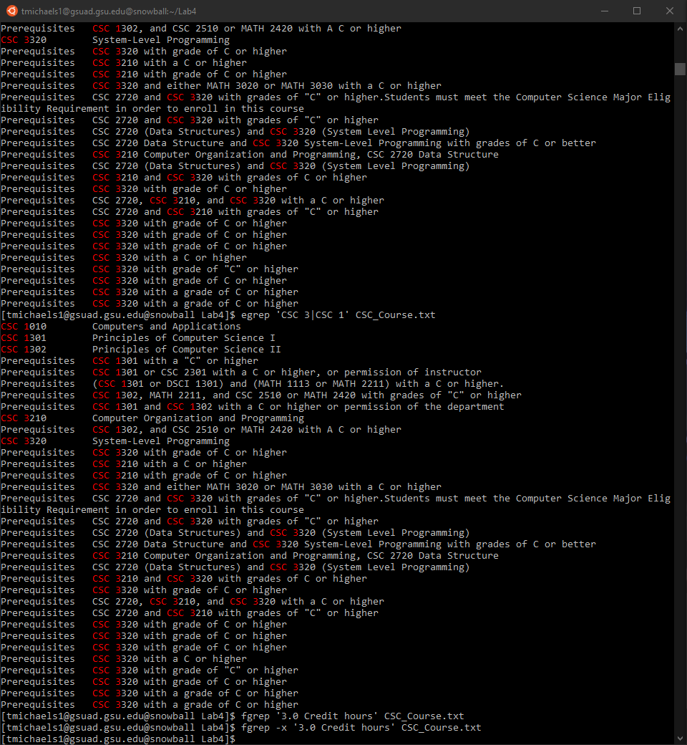

10) outputs lines where strings are matched starting with CSC and ending with Programming

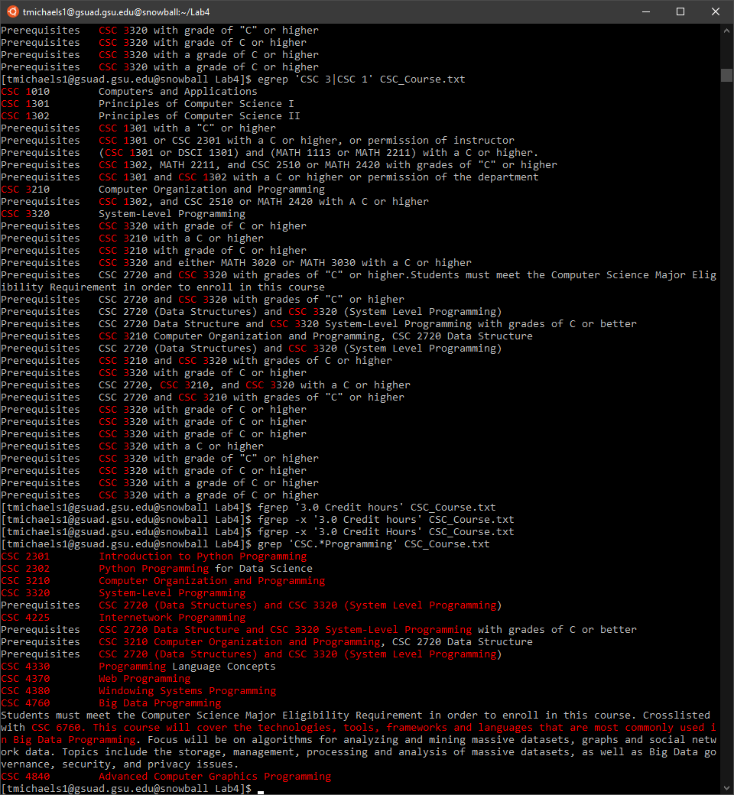

11) outputs lines that begin with ‘CSC’ and end with ‘Programming’

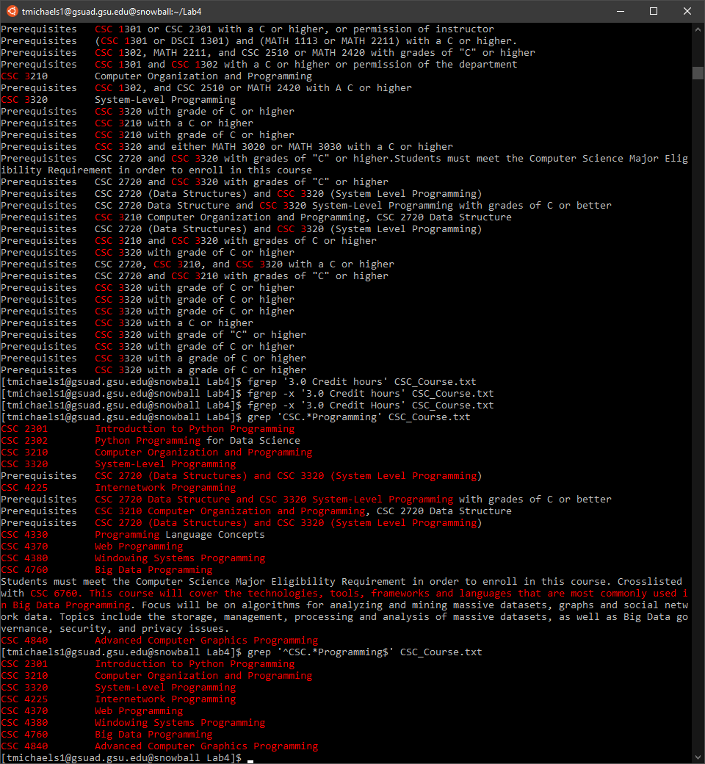

12) outputs nothing as standard grep as some characters aren’t treated as meta characters

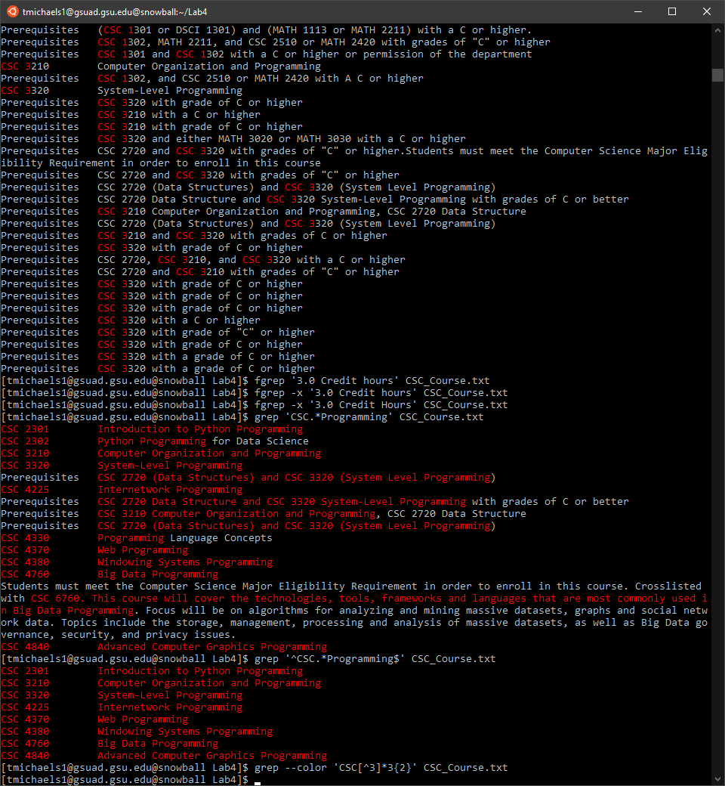

13) outputs lines containing the string starting with CSC followed by any number of characters that are not 3 followed by exactly 2 3’s followed by any number of characters that are not 3

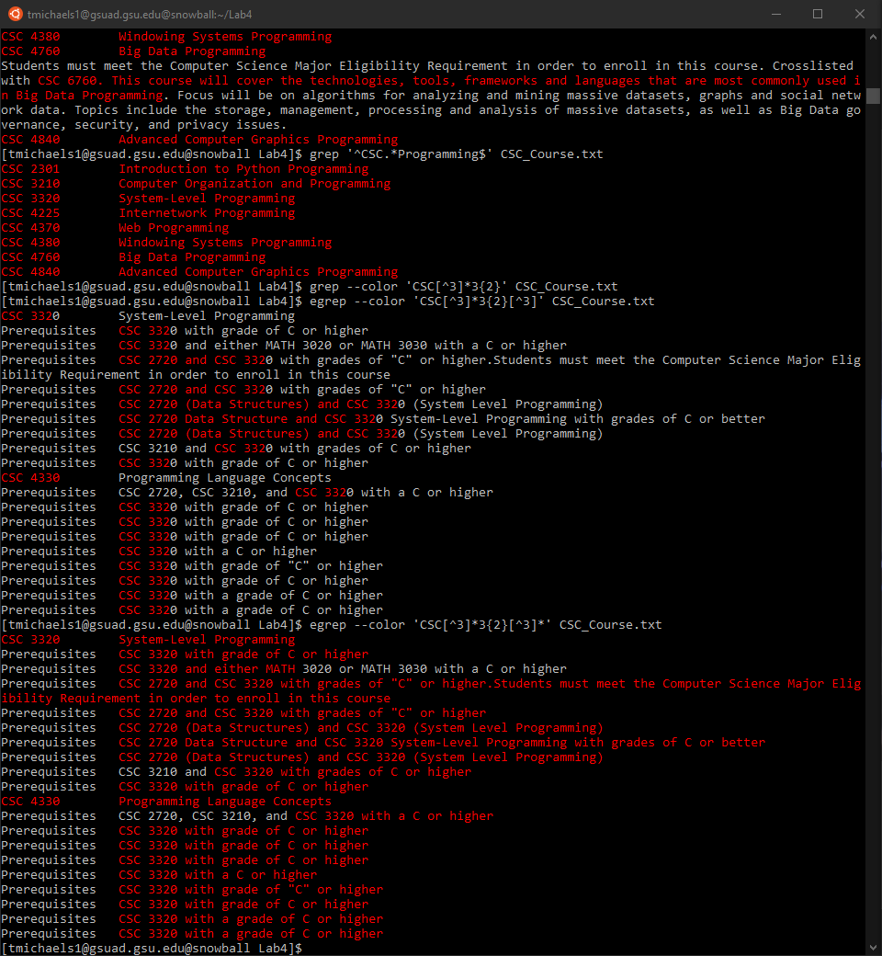

14) outputs nothing

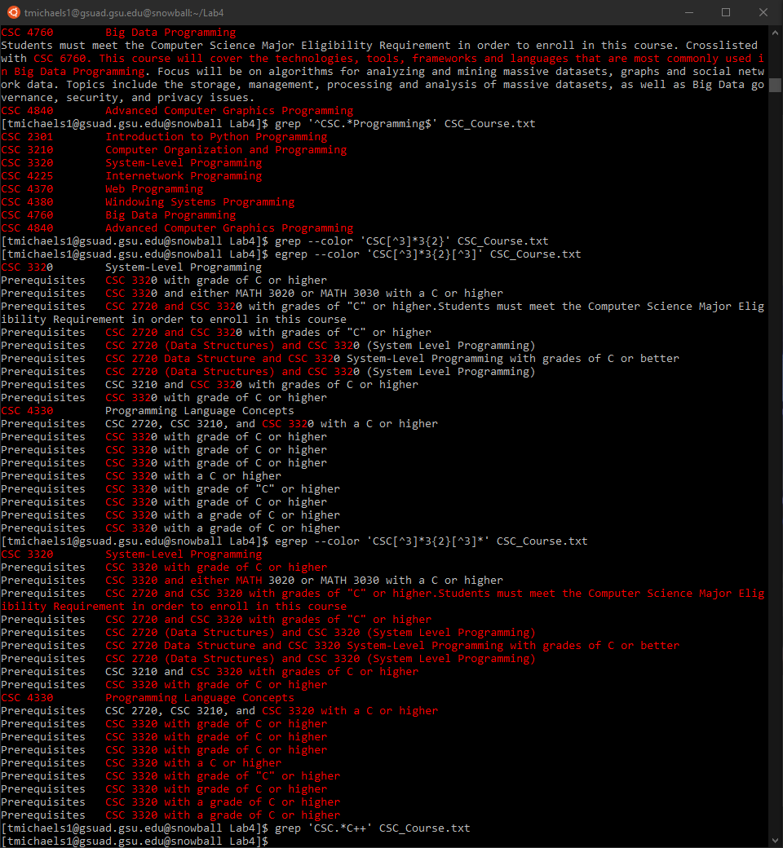

15) outputs nothing

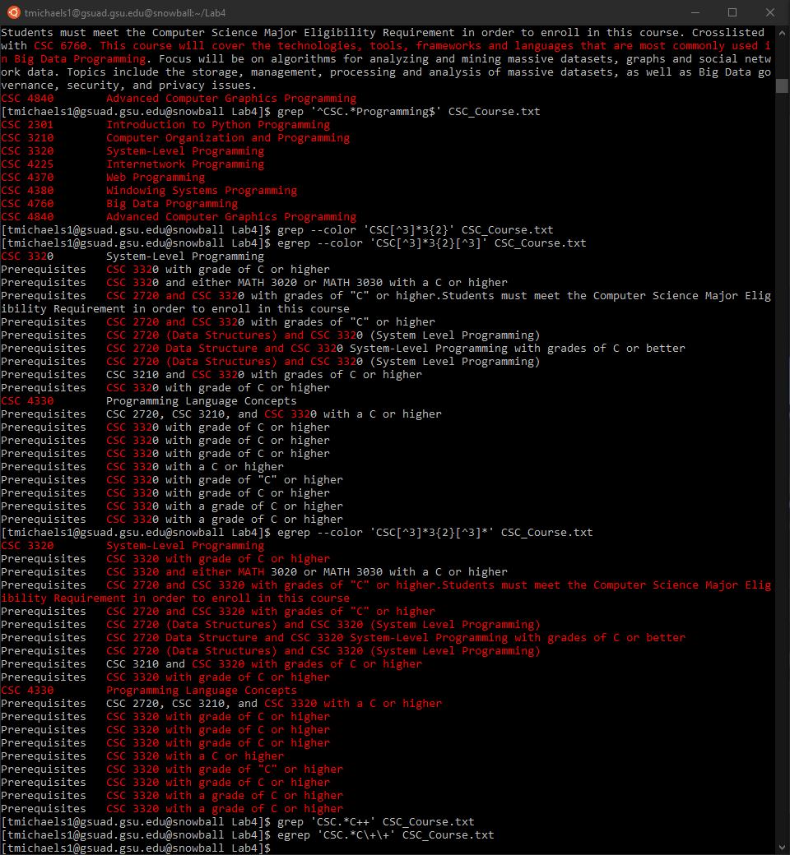

16) outputs lines that contain strings that begin with CSC and end with at least one C

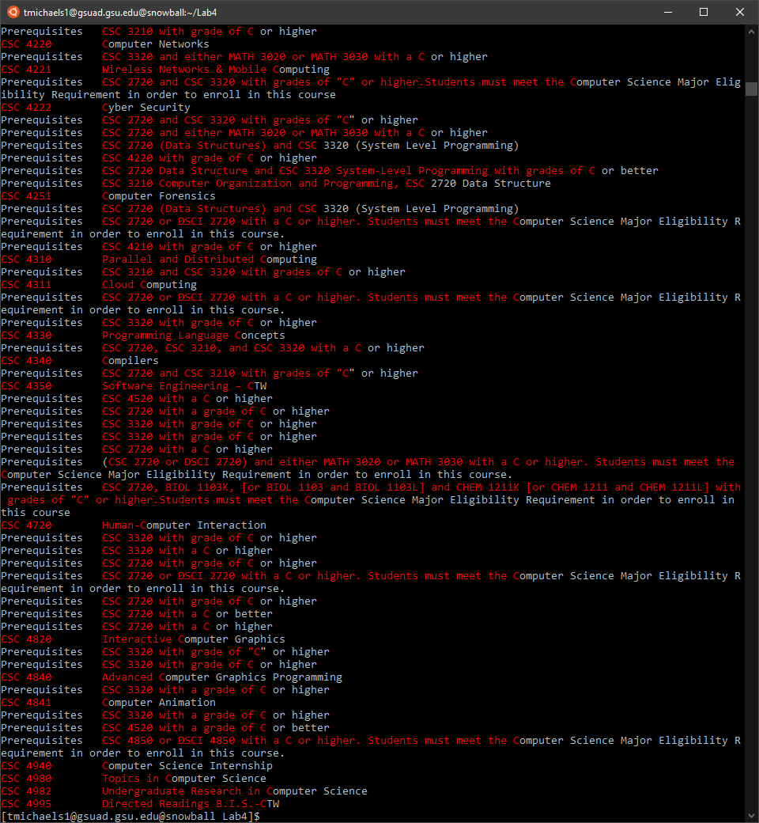

Optional:

1) print text matching first subexpression

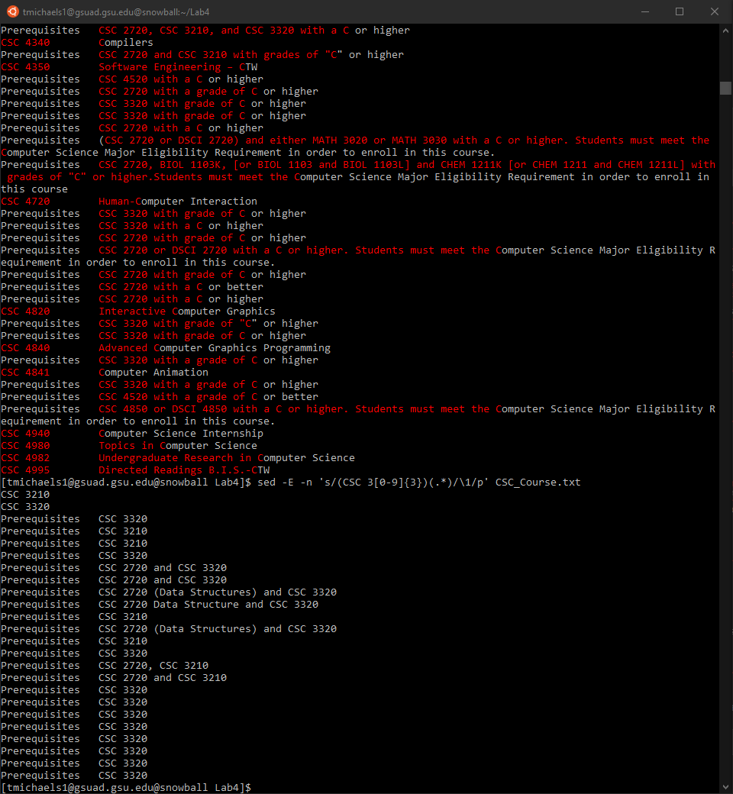

2)

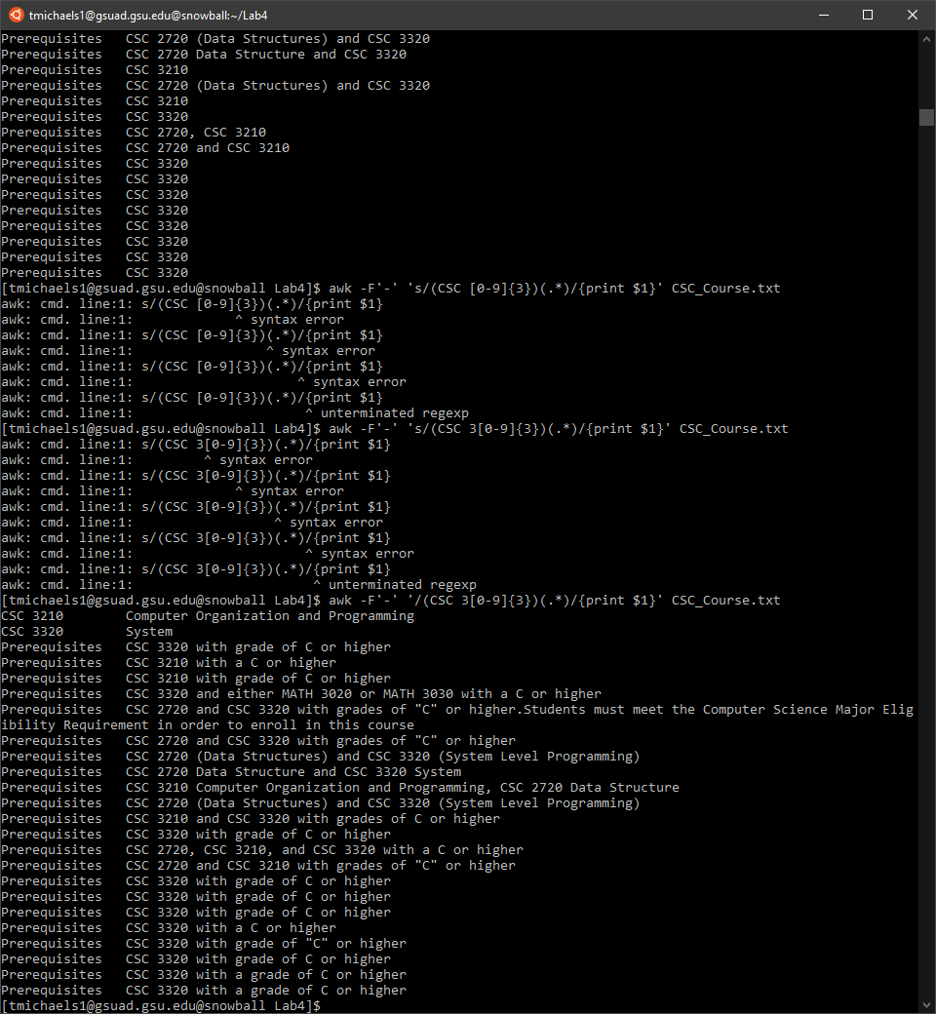

3) outputs nothing

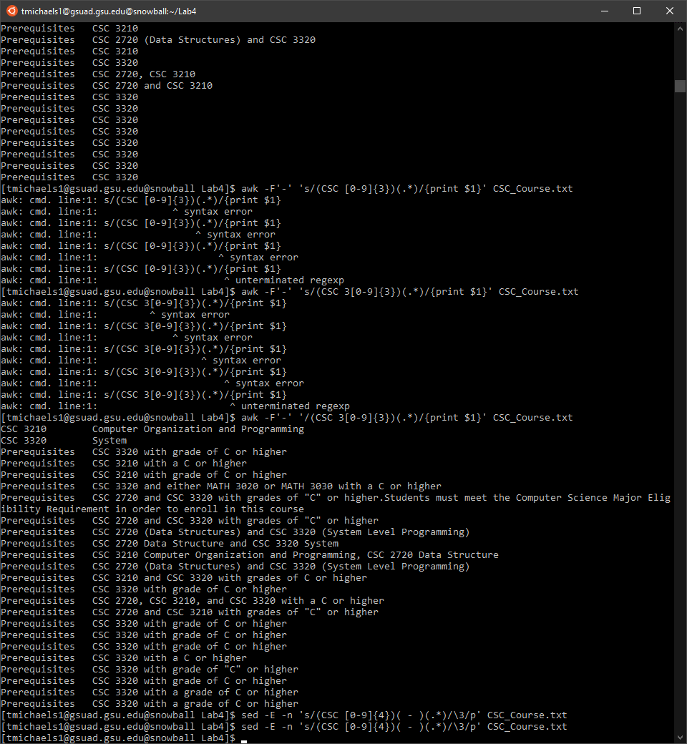

4) outputs nothing

